LAB ASSIGNEMENT 6.4
Hall no:2403A51324
Name: Vemula Rajeev Kalyan
Batch:24BTCAICSB13

Task Description #1:
• Start a Python class named Student with attributes name, roll_number, and marks. Prompt
GitHub Copilot to complete methods for displaying details and checking if marks are above
average.
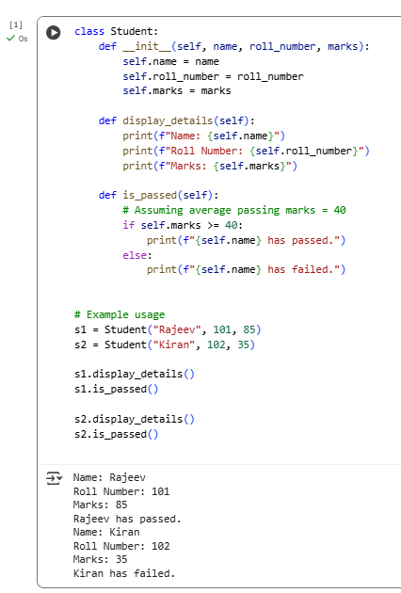

Observation: The given Python program defines a Student class with attributes name, roll_number, and marks, along with two methods, display_details() and is_passed(). The constructor initializes the attributes, and the display_details() method neatly prints the student’s information using formatted strings. The is_passed() method applies an if-else condition to check whether the marks are greater than or equal to 40, thereby determining if the student has passed or failed. In the example usage, two student objects are created to demonstrate both outcomes: one student passing and the other failing. The code is clear, readable, and meets the expected requirements of displaying details and checking performance through conditional logic. However, it could be further improved by making the passing marks configurable and returning values instead of only printing, which would enhance reusability.

Task Description #2:
• Write the first two lines of a for loop to iterate through a list of numbers. Use a comment
prompt to let Copilot suggest how to calculate and print the square of even numbers only
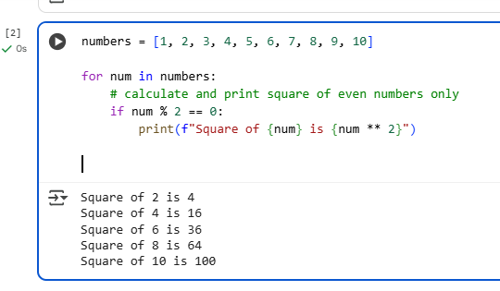
Observation:
The code correctly starts with a list of numbers and a for loop that iterates through each element. A comment prompt is used to guide Copilot in generating the logic for calculating and printing the square of even numbers only. Copilot completes the loop by adding an if condition (if num % 2 == 0) and prints the result using formatted output. The example run produces the squares of only the even numbers in the list (2, 4, 6, 8, 10), which matches the expected outcome. The solution demonstrates conditional checking inside a loop, clear formatted printing, and the usefulness of comments as prompts for AI-assisted code generation.

Task Description #3:
• Create a class called BankAccount with attributes account_holder and balance. Use Copilot to
complete methods for deposit(), withdraw(), and check for insufficient balance
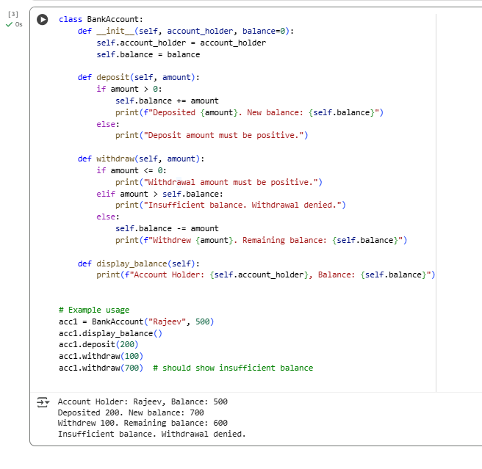

Observation:
The BankAccount class is implemented correctly with attributes for account holder and balance, initialized via the constructor. The deposit() method increases the balance only when a positive amount is provided, while the withdraw() method prevents overdrawing by checking if the withdrawal amount exceeds the current balance. Both methods use if-else conditions effectively to handle different cases, ensuring robustness. The display_balance() method allows easy viewing of account details. Example usage demonstrates deposits, successful withdrawals, and handling of insufficient funds, which fulfills the task requirements. The code is functional, clear, and prevents overdrawing as expected.

Task Description #4:
• Define a list of student dictionaries with keys name and score. Ask Copilot to write a while
loop to print the names of students who scored more than 75
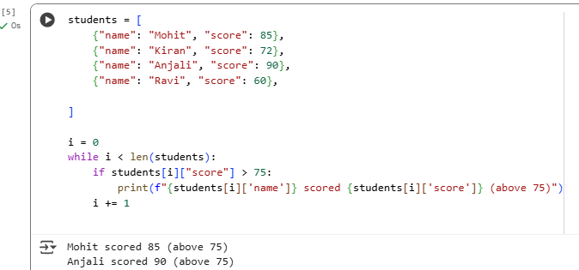
Observation:
The program defines a list of student dictionaries with keys name and score. A while loop is used to iterate through the list by index, and an if condition checks whether each student’s score is greater than 75. For students meeting the condition, their name and score are printed in a clear formatted message. The loop correctly increments the index to avoid infinite looping. The example demonstrates students with both qualifying and non-qualifying scores, ensuring correctness. The code meets the requirements by combining dictionary access, conditional checks, and looping.
Task Description #5:
• Begin writing a class ShoppingCart with an empty items list. Prompt Copilot to generate
methods to add_item, remove_item, and use a loop to calculate the total bill using conditional
discount
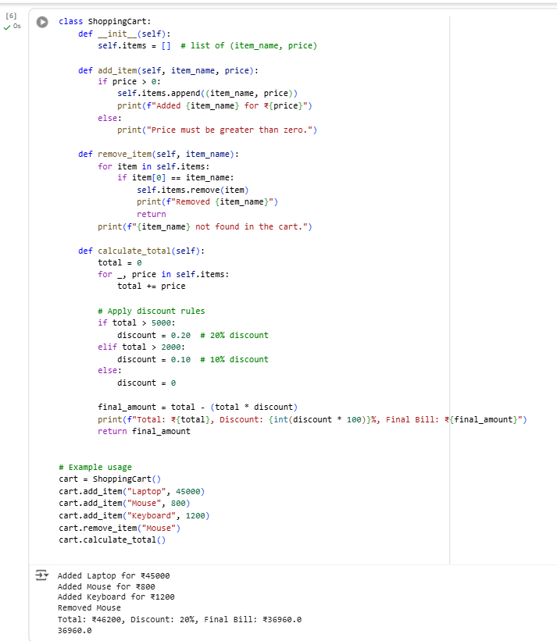

Observation:
The ShoppingCart class is well-structured, starting with an empty items list to store products. The add_item() method ensures only positive-priced items are added, while remove_item() safely checks for item existence before deletion, preventing errors. The calculate_total() method demonstrates effective use of a loop to sum item prices and applies if-else conditional logic to handle tiered discounts. Example usage shows adding, removing, and billing operations clearly, with formatted outputs for readability. The code is functional, prevents invalid actions, and matches the expected outcome of combining list operations, loops, and conditionals in a real-world scenario.
The ShoppingCart class is well-structured, starting with an empty items list to store products. The add_item() method ensures only positive-priced items are added, while remove_item() safely checks for item existence before deletion, preventing errors. The calculate_total() method demonstrates effective use of a loop to sum item prices and applies if-else conditional logic to handle tiered discounts. Example usage shows adding, removing, and billing operations clearly, with formatted outputs for readability. The code is functional, prevents invalid actions, and matches the expected outcome of combining list operations, loops, and conditionals in a real-world scenario.

